1.How to check docker desktop is running or not .by using the below command we will check and run docker images.
docker run -d -p 8080:80 docker/welcome-to-docker
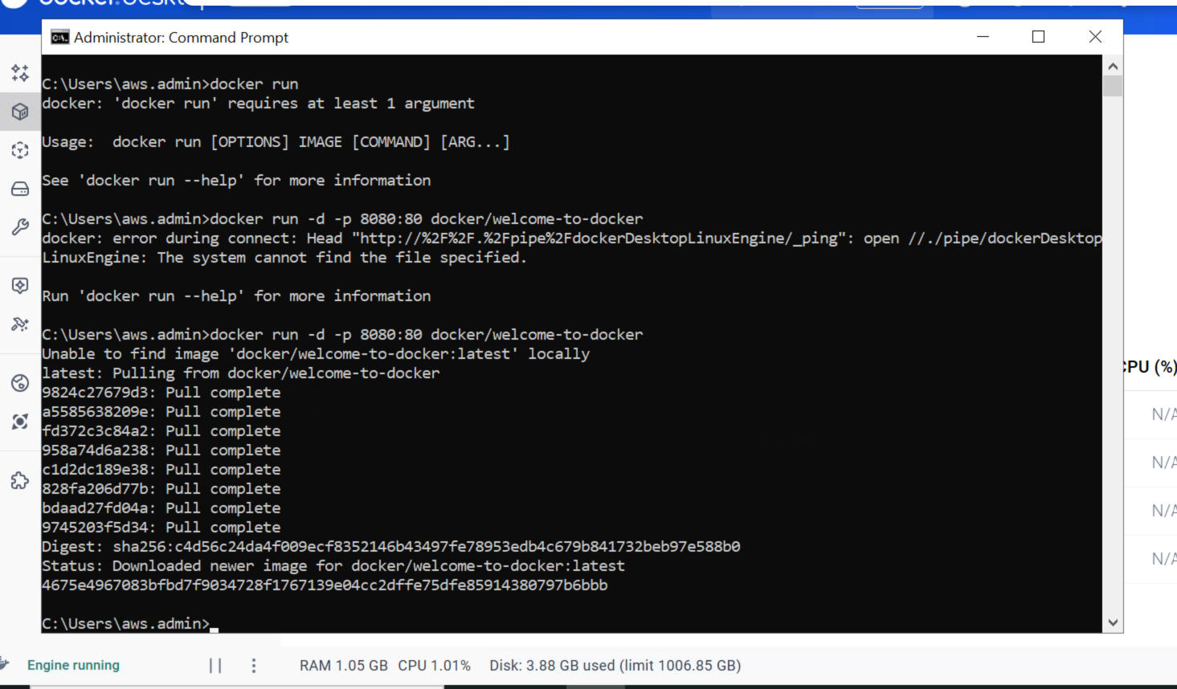

2.To check whether the above front end is accessible or not by using the URL below

http://localhost:8080

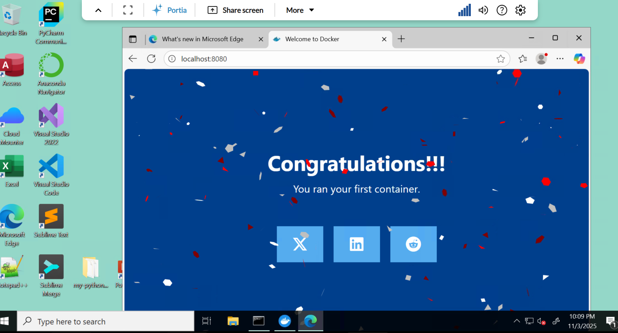
3.List of all containers running in docker desktop
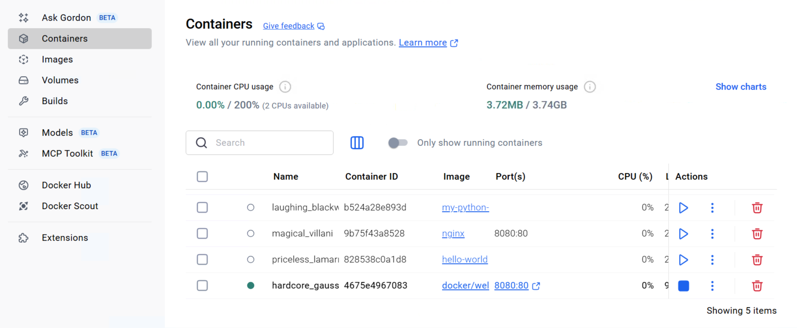

4.WE can find the detailed log details about containers by clicking on view details .
Select the Inspect field to obtain detailed information about the container. You can perform various actions such as pause, resume, start or stop containers, or explore the Logs, Bind mounts, Exec, Files, and Stats tabs.

